Paper ID: | 5270
Copyright Transfer Form

Title of the submitted paper: | Digital Archives Supporting Document Content Inference
The authors hereby transfer, assign and otherwise convey full Copyright in and to the manuscript named above in all forms and media, now or hereafter known, to the MIPRO Croatian ICT Society (MIPRO) effective if and when the paper is accepted for publication in MIPRO Proceedings (official proceedings of MIPRO 2019 convention).
Everyone who is listed as an author in this article should have made a substantial, direct, intellectual contribution to the work and should take public responsibility for it. If there is more than one author, the corresponding author is responsible for obtaining the signatures of all co-authors.
By signing this document, authors grant that this paper contains works that have not been previously published or are not under consideration for publication in other proceedings or journals.

Corresponding author: | Evgeny Cherkashin |  |  |  | 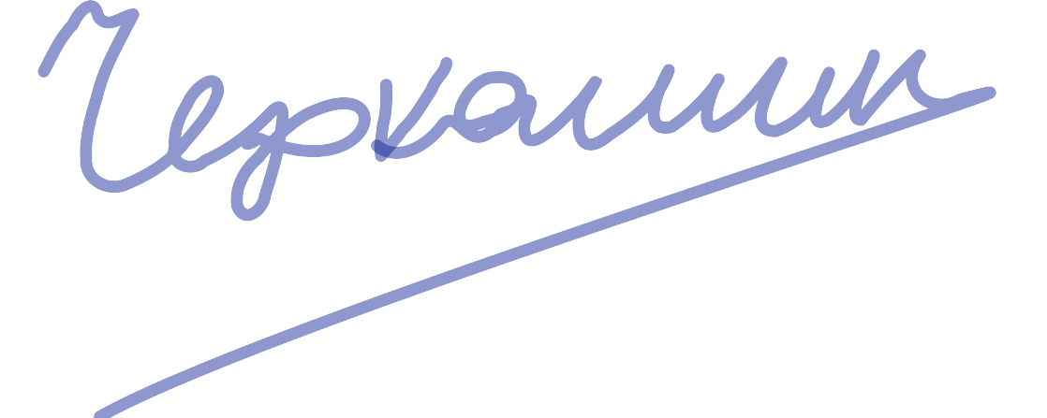  08-May-2019
 | Name |  | Signature |  | Date

Authors (in order of appearance in the article):
 | Evgeny Cherkashin |  |  |  | 08-May-2019
 | Name |  | Signature |  | Date
 | Alexey Shigarov |  |  |  | 08-May-2019
 | Name |  | Signature |  | Date
 | Viacheslav Paramonov |  |  |  | 08-May-2019
 | Name |  | Signature |  | Date
 | Andrey Mikhailov |  |  |  | 08-May-2019
 | Name |  | Signature |  | Date

